**Machine Learning Algorithms**

Is it Supervised/Unsupervised/Reinforcement learning?

•What does the algorithm do?

•In which situations will it be most useful?

•(Optional) Can you find any examples of where this algorithm has been used?

**Linear Regression**

Linear Regression is a machine learning algorithm that is based on supervised learning. The algorithm uses information from independent variables (X) to predict the values of dependent variables (Y). From this information, a line of best fit is created on the chart, which gives the machine the ability to make predictions of y as the algorithm represents values within a continuous range on a constant slope.

The following equation is used in the algorithm:



**When training the model, the model is given the X, the independent variable, and Y values, output data for training purposes. The model then gets the best regression line by finding the intercept and the coefficient value for X. Once the model creates the best fit line, we are able to predict the value of Y based on values for X.**

**The values discussed above are constants in the equation. The error term in the equation represents a non-constant value and is used to represent the degree of error or the distance between the actual points on the scatter graph and the regression line. Therefor, the error term will reflect the outliers, measurement errors, omitted variables, and nonlinearities.**

**The following equation, which uses the mean, can be used to predict the error:**



**Linear Regression is most useful in predicting and forecasting, when the input variables and the output variables have a linear relationship. It is used in a number of fields including business, medicine, and agriculture. A real-life example of Linear regression in use within a business context may be to look at the correlation between the amount of money spent on advertising and revenue created as a result of this spending.**

<https://www.statisticshowto.com/error-term/>

<https://www.geeksforgeeks.org/ml-linear-regression/>

<https://machinelearningmastery.com/linear-regression-for-machine-learning/>

<https://ml-cheatsheet.readthedocs.io/en/latest/linear_regression.html>

**Decision Trees**

**The decision tree is one of the most popular algorithms used in machine learning. It is a supervised method of machine learning in which the machine uses previous decisions made on input, training data to predict future decisions.**

**A decision tree is made up of the fragmentations from a centra node. The starting point of the diagram is the Root note which is where the population or the data begins to fragment. After the root node, the population splits into decision nodes which then move further into leaf nodes which is where the population is no longer split up any further and the final decision is made.**

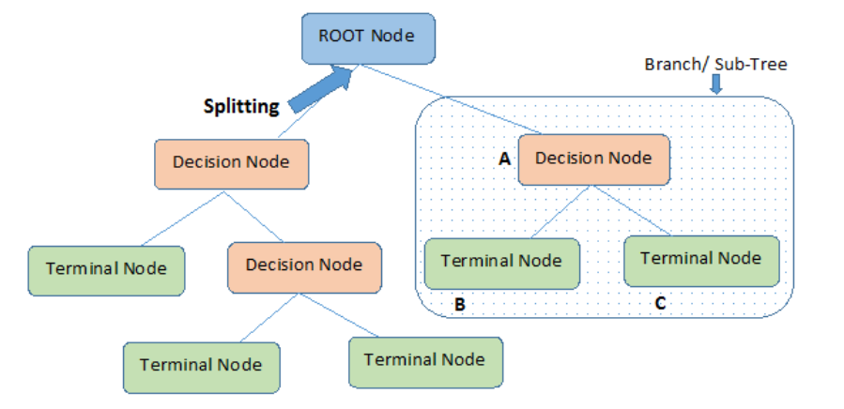

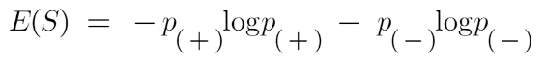**In order to make the decision of whether the node should be split into further decision nodes or a leaf node is based on entropy, or the degree of uncertainty in the dataset or the measure of disorder in other words. Entropy is measured with the following equation:**

**Here, p+ is the probability of a positive class, p- is the probability of a negative class, and S is the value from the training examples. The higher the value for Entropy given from the previous example the more likely that the node will need to be further split, or pruned, to give further choices for the categorization of the data, and limit the possibility of over generalising the output.**

**Decision trees are useful for managing non-linear data sets where outcomes are based on certain conditions being present. Data trees are used in a number of industries, including business, finance, engineering, and law. One real time example of using a decision tree may be looking at potential clients in finance or insurance. They may be used, for example, to look at demographic data to define prospective clients, then, the business would be able to focus their marketing budget on a specific group within a company. In insurance, a firm may use decision trees to decide on the risk of a potential client depending on certain conditions.**

<https://corporatefinanceinstitute.com/resources/knowledge/other/decision-tree/>

<https://www.analyticsvidhya.com/blog/2021/08/decision-tree-algorithm/>

<https://www.kdnuggets.com/2020/01/decision-tree-algorithm-explained.html>